Product Innovation

Title: COVID-19 Detection System: AI-Powered Clinical Diagnostic Platform for COVID-19 Detection using Deep Learning and Explainable AI

- Introduction

The presented product introduces an innovative AI-driven solution for the automated diagnosis of COVID-19 and related pulmonology conditions via chest X-ray images. Unlike other machine learning solutions that rely on one predictive algorithm, this system integrates several deep learning models, explainable AI components, and a number of scalable deployment options to ensure maximum interpretability, usability, and adaptability. In addition to delivering accurate predictions, the system's aim is to be reliable and useful to medical specialists when used in their clinical practices.

To train the proposed deep learning model, thousands of chest X-rays with labels were employed in this project. This data helps the model to identify several classes: COVID-19, normal lungs, viral pneumonia, and lung opacity. What makes this innovation different from traditional solutions is that this platform utilizes the power of a multi-model ensemble mechanism that involves the analysis of the same input image by several different models that reach a conclusion.

Along with improving the performance of the predictive process, this feature adds another layer of reliability to the diagnostic process since more than one model has to make the same decision for it to happen. Besides achieving the highest level of prediction accuracy, the system emphasizes the importance of being transparent and explainable. Clinicians expect a detailed explanation for each predicted class to help diagnose the patient and take further action.

A developed implementation of the current work is present at the following link:
https://github.com/ssdafeef/PulmonaryAI

Problem Statement
Current AI-based diagnostic solutions have faced some critical issues within the healthcare domain that limit their usage within clinical practice. One of the most prominent problems lies in using a single deep learning model that makes them prone to bias. Considering that any errors that the system makes will directly affect the health and life of patients, it is crucial to develop a reliable solution to deal with such a problem.

In addition, some diagnostic systems are primarily designed for research purposes and thus do not reflect real-life processes of working with medical data and making diagnoses. For example, they lack scalability and do not offer an opportunity to integrate the tool into existing systems and software solutions. In reality, there is a variety of steps required to be taken for diagnosing, such as data validation, collaboration, and structuring.

Another challenge of the current AI diagnostic solution is its inability to manage uncertainty. Current technologies tend to produce overconfident predictions that may influence practitioners' decisions in a wrong way. Moreover, there is a lack of some practical features, like generating reports, classification of the disease severity level, and multi-language support.

Moreover, such systems do not use any approaches for uncertainty management or providing confidence scores, making predictions highly overconfident. Another important point is the lack of other useful features like automated report generation, severity categorization, or multilinguality, which makes these solutions not usable in practice. Hence, the aim of this project is to develop a system that will have all those shortcomings addressed.

Proposed Solution
The proposed system represents a hybrid AI solution incorporating the latest advancements in deep learning, explainable artificial intelligence, and deployment frameworks in order to deliver a full-fledged clinical decision support system for chest X-ray image assessment. As the core component of the system, a convolutional neural network with a special attention module is used. The chosen network structure is ResNet50.

For increased reliability of the solution, a multi-model ensemble method will be utilized. It will consist of several independent neural networks performing predictions based on a provided image. Then, using a certain algorithm, a consensus between the predictions generated by individual networks will be achieved. Thus, only the most confident predictions from different networks will make their way to the final result. This is inspired by the process of collaborative work of physicians in reality, where a team of specialists contributes to a final decision.

The problem of interpretability and explanation of predictions will also be solved using explainable artificial intelligence techniques. Grad-CAM algorithms will allow generating visual explanations represented by the heatmaps showing what parts of the image influenced the decision of the classifier. Moreover, a separate language model will be able to generate a natural-language explanation of a predicted diagnosis. It will be accompanied by the reasoning behind the prediction, its consequences, and possible further actions.

Automated generation of reports with all predictions and explanations will be implemented as another crucial feature. Reports generated by the solution will be in the PDF format, containing all data regarding the analysis of a chest X-ray image, including severity level. Moreover, there will be multilingual capabilities of the solution, along with a severity classification system.

System Workflow
The operation of the system involves a pipeline workflow simulation that resembles a realistic diagnostic scenario. The procedure starts by uploading a chest X-ray image through the web application. It is designed to allow easy interaction for both experienced and non-experienced users.

Once the image is uploaded, it is preprocessed in the backend environment. It includes image size rescaling, normalization of the image's pixel values, and conversion to a specific format. Proper preprocessing is vital for achieving consistent and reliable performance of AI models.

Further, the image is subjected to the analysis of several AI models. Each of them independently provides probability outputs related to different classes. Outputs of different models are combined using the technique of voting. If there is consistent behavior between the models, a certain classification result with high confidence level is obtained. However, in case of discrepancy, the system informs about the inconsistency and suggests additional analysis. After the prediction, the system uses explainable AI and provides heatmaps highlighting the most influential areas in the image. Further, an AI-driven natural language explanation of the results is generated by the language model.

Additionally, the system performs severity classification for COVID-19 infection cases. As a final step, all information is aggregated and provided via the interface. A PDF document containing information related to the diagnosis is prepared automatically and ready for download.

Key Innovations
- AttentionResNet50 with a custom attention mechanism for COVID-19 classification
- Hybrid inference approach using NVIDIA Triton Inference Server and local Keras models
- Explainable AI based on the Grad-CAM visualization of every prediction
- Voting between multiple inference branches based on the confidence in prediction
- Ai-powered explanation using a language model (LLM; Google Gemini)
- Automated PDF report generation with multi-language support
- Four-class classification of Chest X-rays: COVID-19, Normal, Viral Pneumonia, Opacity
- Accuracy ~94%, ~0.97 AUC-ROC on 21,165 chest X-ray images
- Severity classification for COVID-19 infections (mild, moderate, severe)
- Fully deployed system using Docker Compose
- Model serving on NVIDIA Triton Inference Server
- End-to-end AI pipeline for uploading images and generating PDF reports

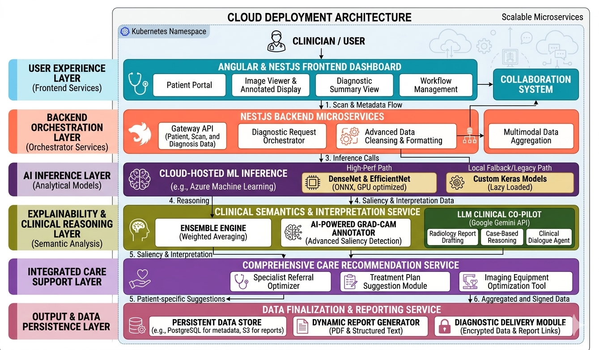
Figure 61: Architecture Diagram of model

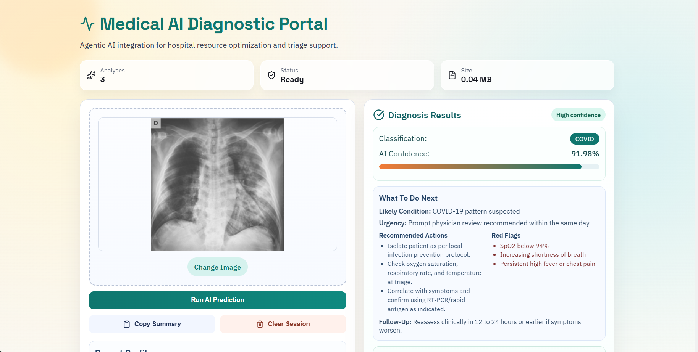
Figure 62: X-ray prediction output showcasing result

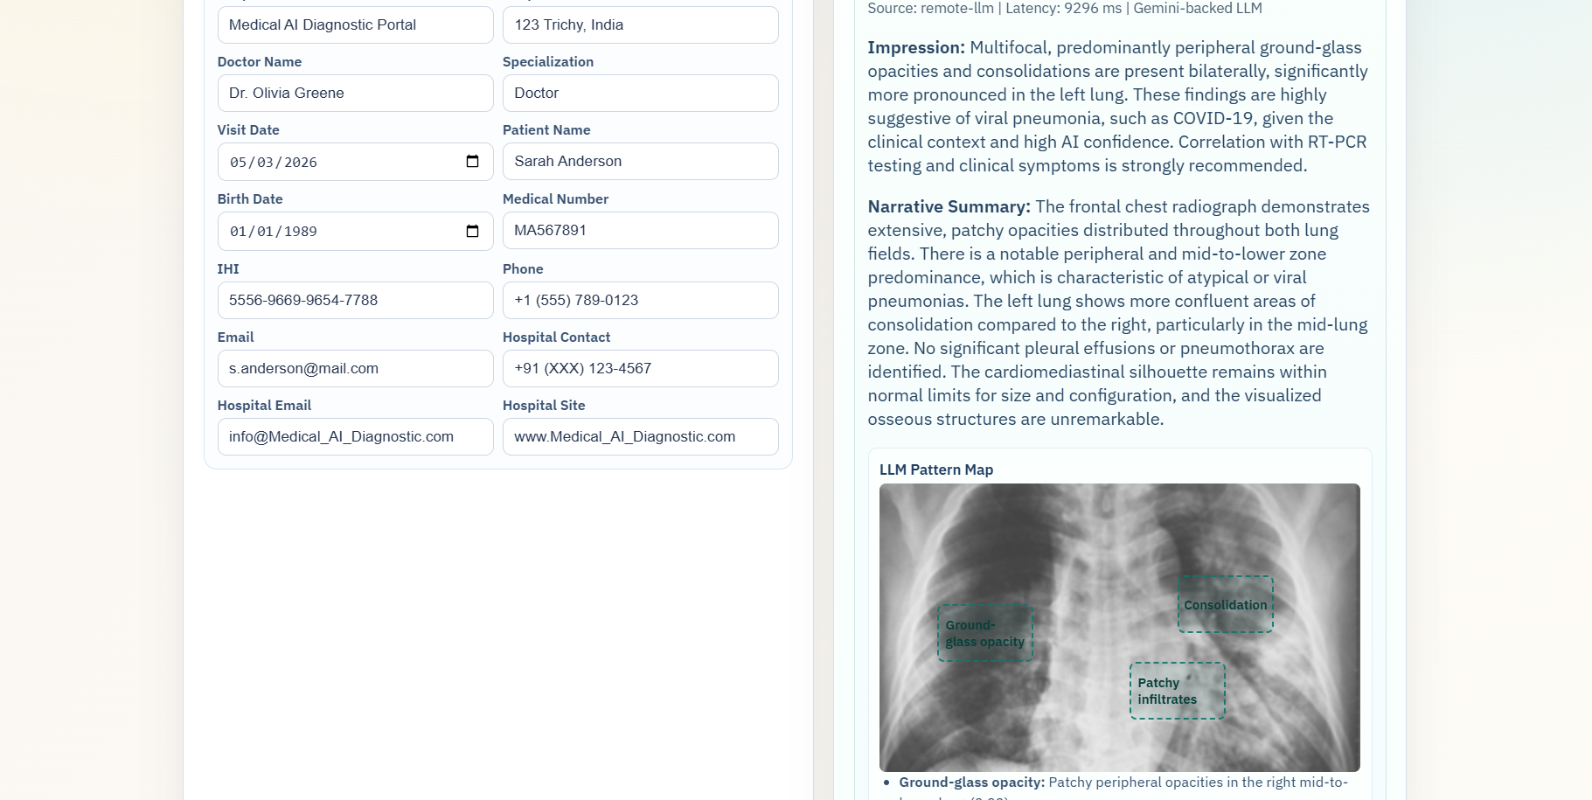
Figure 63: The LLM model showcasing overlay of detected area

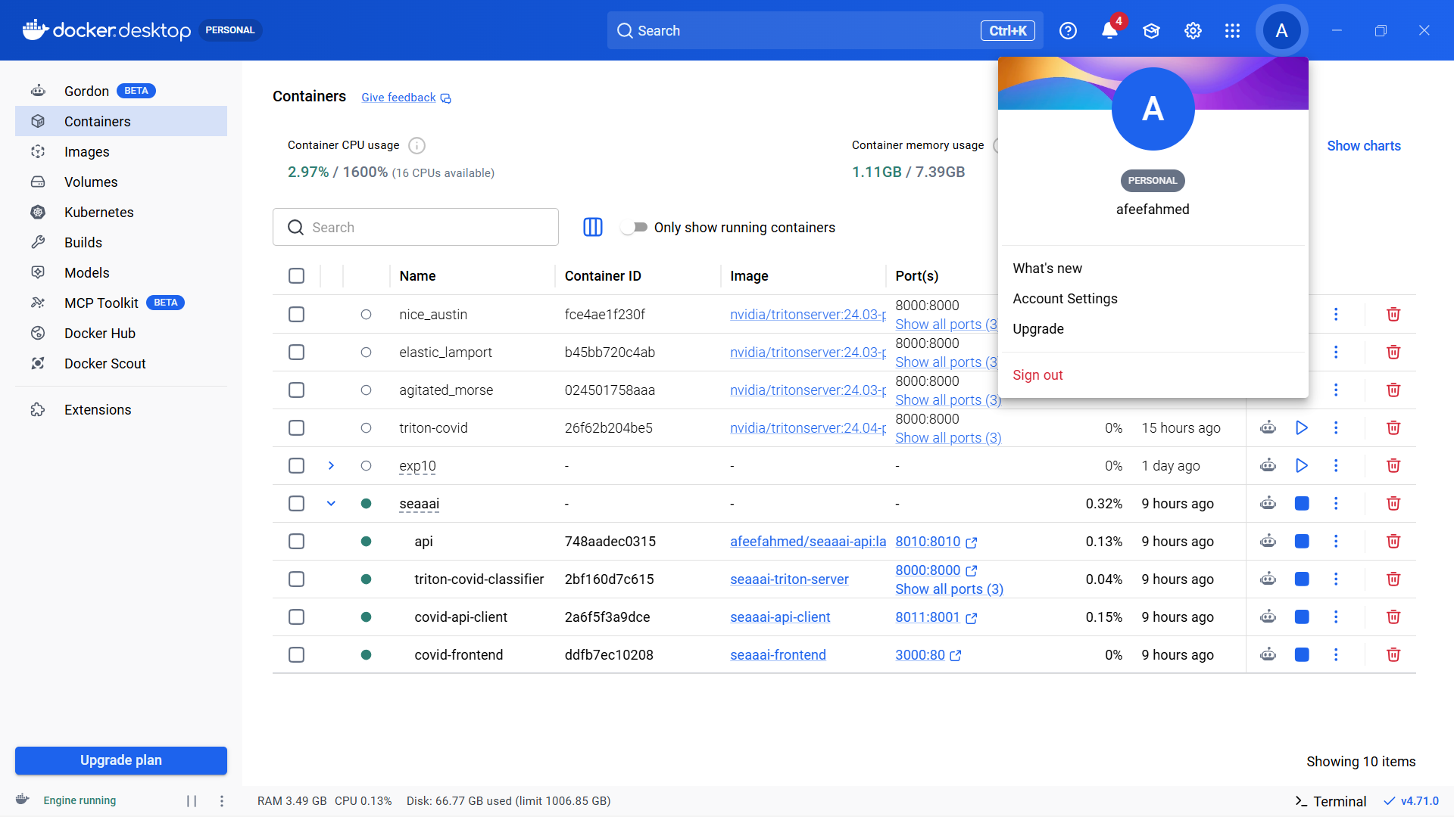
Figure 64: The Whole Project running on docker

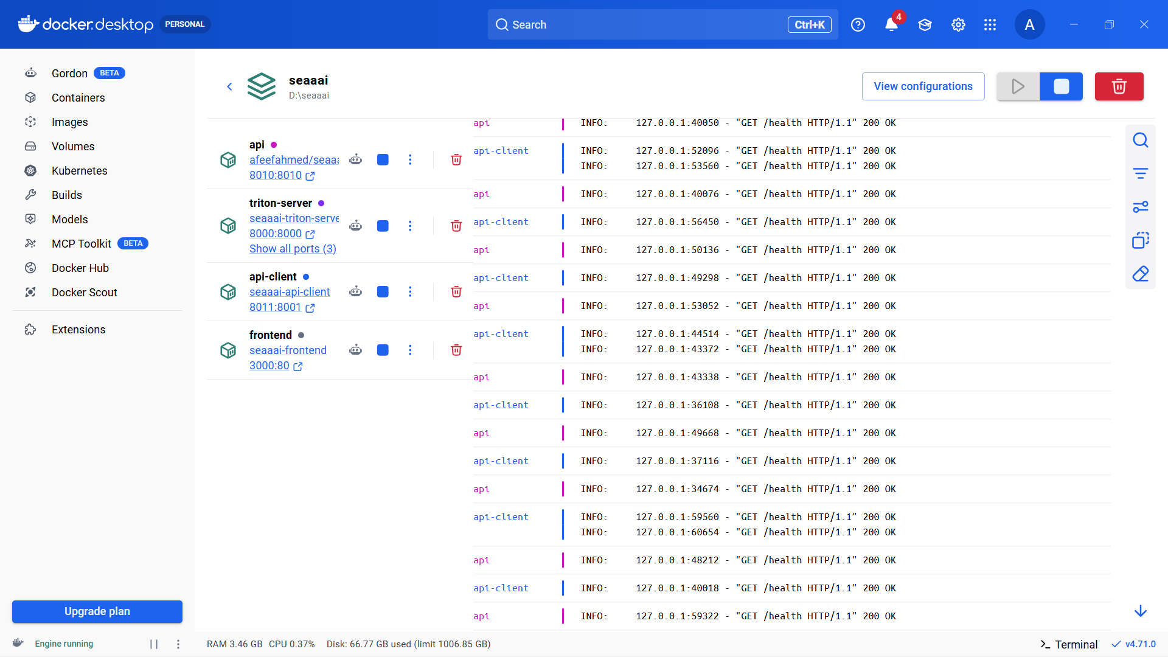
Figure 65: All the container inside docker container

Dataset and Training Details
The creation of the proposed COVID-19 Detection System is possible because of the COVID-19 Radiography Database, which is the commonly-used dataset for medical image classification tasks. It includes numerous chest radiography images grouped into several classes: COVID-19, Normal, Viral Pneumonia, and Lung Opacity. The presence of over 21,000 images makes it diverse enough to train the system with deep learning methods.

The dataset has training, validation, and testing samples to ensure the possibility of reliable evaluation of the system's performance. For example, the training subset is utilized to train models and learn necessary patterns, while the validation one monitors the learning process and prevents overfitting. At last, test data is used to assess the results and estimate the performance in real-world conditions.

To enhance the performance of models, multiple preprocessing techniques are applied. They include resizing images into standard input dimensions (224 × 224 pixels) and pixel values normalization. Some other techniques used are rotations, flips, and scaling of images to diversify data. Finally, because of class imbalance, class weighting was applied during the learning stage to ensure fair results.

Deep learning models are trained using TensorFlow library in Google Colab equipped with GPU. Transfer learning is used to pretrain the models on pretrained architectures such as ResNet50 and DenseNet121. The best performance of models trained with transfer learning and without it are compared. Moreover, class weighting and standard training techniques are also explored.
The accuracy score reaches about 94% when using the most productive approach. Thus, the selected combination of techniques yields impressive results and ensures an accurate system.

In general, with an extensive dataset, numerous preprocessing techniques, transfer learning, and GPU utilization, the developed system is highly accurate and reliable.

Deployment and Scalability
To provide scalability and portability to the developed system, a number of techniques can be used. They include the creation of self-contained units, packaging of components into containers, and implementing cloud computing capabilities. All mentioned elements are present in the design of the system, making it scalable and portable.

A high-performance inference server is utilized to efficiently process numerous requests and perform in real-time environment. Additionally, because of the hybrid architecture, the system works in environments with or without GPUs. The use of container orchestration makes it easy to scale the system up to handle higher loads.

By implementing such technologies as container orchestration, the system can easily scale to process higher volumes of data. Therefore, the solution can be deployed in hospitals, scientific centers, and even in remote medical centers. Generally speaking, the deployment approach enables the creation of an AI tool that is powerful and pragmatic.

Real-World Impact
With its help, the diagnosis of such diseases as coronavirus infection, lung inflammation, and other related conditions can be carried out with precision and accuracy. Furthermore, the AI-driven diagnostic tool will make it easier for specialists to make informed choices since the system offers both the results and explanations. It may serve as an additional aid to those parts of the world where experienced radiologists cannot be found.

The use of such a system can positively affect healthcare through improved speed and quality of diagnostics. Moreover, the possibility of generating structured reports and evaluating the severity of symptoms increases the efficiency of the entire diagnostic process.

Conclusion
This paper has offered an insight into developing a powerful system designed to help people get reliable diagnoses. Such a tool combines various modern approaches used in machine learning and can provide useful solutions for medical diagnostics.

The project can be seen as an example of the successful application of artificial intelligence in solving complex problems and creating helpful applications for everyday practice

